/*1:Create Date class with members day,month ,year. Write no argument and parameterised constructor .Create two object s and initialize them using no argument and parameterised constructor respectively.Print date using display function.*/
#include<iostream>
using namespace std;
class Date{
private:
int day, month, year;
public:
Date(){
day = 1;
month = 1;
year = 1000;
}
Date(int day, int month, int year){
this->day = day;
this->month = month;
this->year = year;
}
void display(){
cout<<"Date: "<<day<<"/"<<month<<"/"<<year<<endl;
}
};
int main(){
Date d1;
d1.display();
Date d2(14, 9, 2023);
d2.display();
return 0;
}
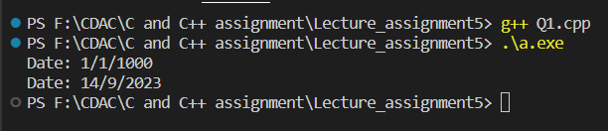

/*2:Create Employee class with members id(int),name(string),dob(Date).Use above created Date class. Write default and parameterised constructor in Employee Class.Write accept() function to accept information and display() to display emp information.*/
#include<iostream>
#include<string>
using namespace std;
class Date{
private:
int day, month, year;
public:
Date(){
day = 1;
month = 1;
year = 1000;
}
Date(int day, int month, int year){
this->day = day;
this->month = month;
this->year = year;
}
void acceptDate(){
cout<<"Enter day: ";
cin>>day;
cout<<"\nEnter month: "<<endl;
cin>>month;
cout<<"\nEnter year: "<<endl;
cin>>year;
}
void displayInfo(){
cout<<"Date: "<<day<<"/"<<month<<"/"<<year<<endl;
}
};
class Employee : public Date{
private:
int id;
string name;
public:
Employee(){
id = 101;
name = "Ram";
}
Employee(int id, string name){
this->id = id;
this->name = name;
}
void acceptInfo(){
cout<<"Enter id: ";
cin>>id;
cout<<"\nEnter name: ";
cin>>name;
Date::acceptDate();
}
void display(){
cout<<"\nId: "<<id<<" name: "<<name<<endl;
Date::displayInfo();
}
};
int main(){
Employee emp;
emp.display();
Employee emp2(201, "Suyog");
emp2.display();
Employee emp3;
emp3.acceptInfo();
emp3.display();
return 0;
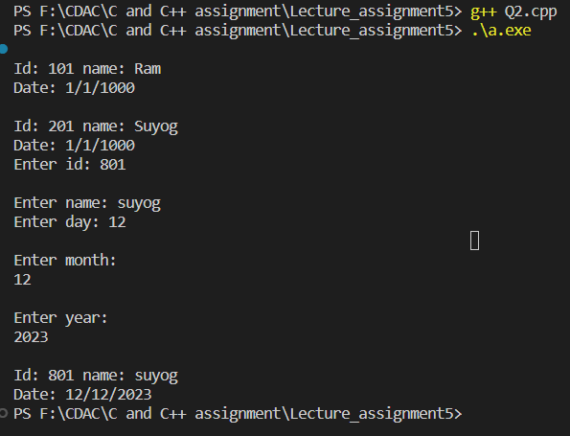
/*3:Consider that payroll software needs to be developed for computerization of operations of an ABC organization. The organization has employees.
3.1. Construct a class Employee with following members using private access specifies:
Employee Id integer
Employee Name string
Basic Salary double
HRA double
Medical double=1000
PF double
PT double
Net Salary double
Gross Salary double
Please use following expressions for calculations://Note:Don't accept HRA,PF PT from user
* HRA = 50% of Basic Salary
* PF = 12% of Basic Salary
* PT = Rs. 200

3.2. Write methods to display the details of an employee and calculate the gross
and net salary.
* Goss Salary = Basic Salary + HRA + Medical
* Net Salary = Gross Salary – (PT + PF)
Create Object of employee class and assign values and display Details.
*/
#include <iostream>
#include<string>
using namespace std;
class Employee
{
private:
int id;
string name;
double basic_salary, HRA, medical, PF, PT, net_salary, gross_salary;
public:
Employee()
{
id = 101;
name = "Ram";
basic_salary = 10;
HRA = 10;
medical = 1000;
PF = 10;
PT = 10;
gross_salary = 100;
net_salary = 100;
}
Employee(int id, string name, int basic_salary, int medical)
{
this->id = id;
this->name = name;
this->basic_salary = basic_salary;
// this->HRA = HRA;
this->medical = medical;
// this->PF = PF;
// this->PT = PT;
}
void calHRA()
{
HRA = 0.5 * basic_salary;
}
void calPF()
{
PF = 0.12 * basic_salary;
}
void calPT()
{
PT = 200;
}
void calGrossSalary(){
gross_salary = basic_salary + HRA + medical;
}
void netSalary(){
net_salary = gross_salary - (PT + PF);
}
void display(){
cout<<"Id: "<<id<<" Name: "<<name<<" Basic salary: "<<basic_salary<<" medical: "<<medical<<" \nPF: "<<PF<<" HRA: "<<HRA<<" PT: "<<PT<<" Gross salary: "<<gross_salary<<" Net salary "<<net_salary<<endl;
}
};
int main(){
Employee emp;
emp.display();
Employee emp2(202, "Suyog", 20000, 1000);
emp2.calHRA();
emp2.calPF();
emp2.calPT();
emp2.calGrossSalary();
emp2.netSalary();
emp2.display();
return 0;
}
